# **May 5, 2018**

**11:00am to 3:00pm**

# **LAASP Retiree and OSP Awards Brunch**





Chart House Restaurant

13950 Panay Way

Marina Del Rey, CA 90292

11:00am – 3:00pm

May 14, 2016

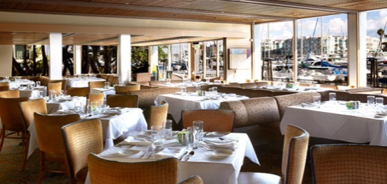



*Join us as we celebrate the retirements of our LAASP members as well as honor Outstanding School Psychologists Award and Scholarship recipients.*

**Retirees:**

Diane Kealoha

Karen Schweibish

Liliana Gonzales

Marnee Brooks

Joan Ruttenberg

Karen Menzie-Wright

Gail Reese

Linda Nelson

**OSP Recipients:**

Zamecia McCorvey- South

Deborah Glezer- West

Molly Onstine - East

Juliet Rodriguez- Northwest

The **cost for brunch is $50.00** which includes a preset menu (alcohol drinks are on your own). **Register on-line at** [**www.lassponline.org**](http://www.lassponline.org) **or pay in person by check or cash at venue.**